E Q 2Perforated Appendicitis
Stem: You see a 45y male in the ER complaining of 5 days of abdominal pain. Pain was initially periumbilical but now is diffuse. For the past 3 days, he has had nausea, vomiting, and fevers. He presents now as he could no longer tolerate oral intake.
Vital signs: Bl. Pr 139/97, HR 118, Temp 39.2°C, RR 19.
Abdomen is nondistended and he has tenderness to palpation in the RLQ with focal rebound tenderness and voluntary guarding.
No PMH or PSH
WBC 18000, Creatinine 1.8

What is your differential diagnosis (Resident should recognize delayed presentation)
- Perforated appendicitis
- IBD related enterocolitis
- Perforated Meckle’s
- Right sided diverticulitis
- Perforated malignancy

What would you like to do?
- CT A/P
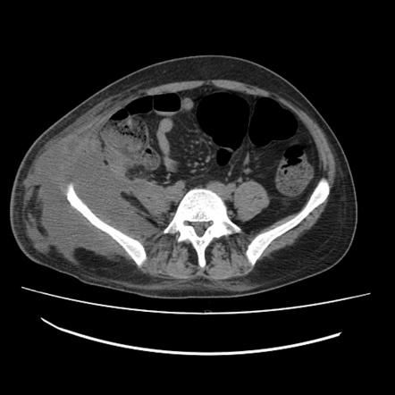

- Fluid bolus, hydration
- Blood cultures, UA
- Broad spectrum Abx.

How are you going to manage this patient?

- Admission
- Continue resuscitation / hydration/ antibiotics.
- IR drainage
(Treatment depends on the extent of the inflammatory process. Though patients with evidence of perforated appendicitis without a large abscess may benefit from appendectomy at the time of presentation. Howeverthis patient has evidence of a large amount of inflammation and free fluid in the RLQ, immediate surgical intervention may do more harm than good. In this setting, appendectomy is associated with a significantly higher rate of complications)

Scenario continues:
Patient gets IR drain next day, WBC improves the day after so as the rest of the labs, pain improves and you advance patient diet, bowel function returns and patient is discharged home, he comes to see you in the clinic and you remove the drain. He comes to see you, now 6 weeks later.
Describes some residual discomfort but not like how it was, you obtain new CT, no residual abscess, now what?

- Plan for a colonoscopy, Describe….
  - Resident should plan to do the colonoscopy themselves, remember to bowel prep the patient and describe steps.

Scenario Continues:
You perform the colonoscopy and apart from 4 mm adenomatous polyp at the sigmoid colon, coloscopy was normal to the cecum, appendiceal orifice seen.

Patient still with RLQ discomfort what would you offer?

Interval appendectomy.

Can you list indications for interval appendectomy?
- Recurrent appendicitis
- Persistent RLQ pain
- Fecalith
- Age over 40 years, and symptoms concerning for malignancy

You take the patient to the OR for laparoscopic appendectomy, during the procedure you decide to open due to adhesions, you make an incision to open at McBurney’s point,
Describe how to perform open appendectomy in general

- Skin incision at McBurney’s point or point of maximal tenderness.
- Open external oblique aponeurosis and bluntly separate internal oblique and transverse abdominis muscles.
- Incise peritoneum.
- Identify appendix and deliver into operative field.
- Divide mesoappendix.
- Place purse-string suture around base of appendix.
- Clamp crush base of appendix and ligate and divide appendix at its base.
- Invaginate appendiceal stump into base of cecum.
- Close in layers

